Dataset 11: Phone Pickups & Inhibition Errors

Scenario Overview
Students reported the number of phone pickups per day. Commission errors on a go/no-go task were recorded as a measure of inhibition.

Data Summary
Phone pickups per day | Commission errors (go/no-go)
10 | 5
20 | 3
30 | 6
40 | 4
50 | 7
60 | 5
70 | 8
80 | 6
25 | 4
55 | 7
65 | 5
35 | 6

Figure
Figure 1. Phone pickups vs errors. Pearson’s correlation (r) = 0.55.
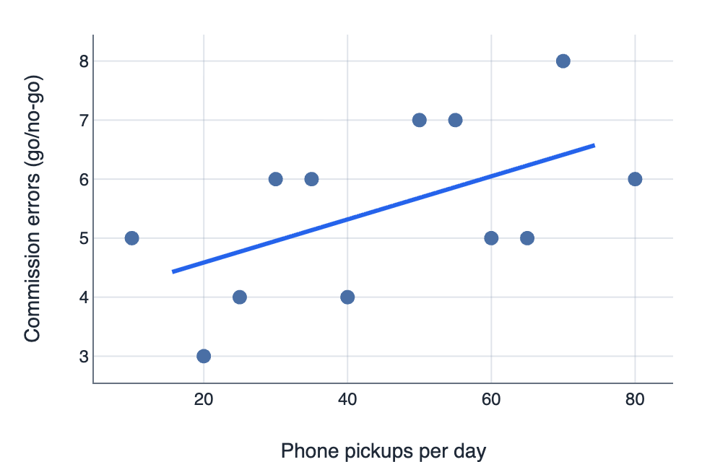

IA1 Practice Questions
- Estimate: Using the line of best fit, estimate the predicted errors at 50 pickups per day.

- Classify: Classify the strength of the relationship using the r-value provided.

- Identify: Identify the trend and describe the variability in the data.

- Infer: Infer what this suggests about inhibition and distraction.

- Justify: Justify one confounding variable.

